**ERROR 1:**

ERROR: Could not install packages due to an EnvironmentError: [Errno 2] No such file or directory:

Common Error on Windows.

**Solution:** Make sure you Disable python Max path length limit.

**ERROR 3:**

Error: Could not locate a Flask application. You did not provide the "FLASK_APP" environment variable, and a "wsgi.py" or "app.py" module was not found in the current directory.

**Solution**: On Windows use **SET** instead of **Export**

**Error:** Failing to connect to MySQL Database.

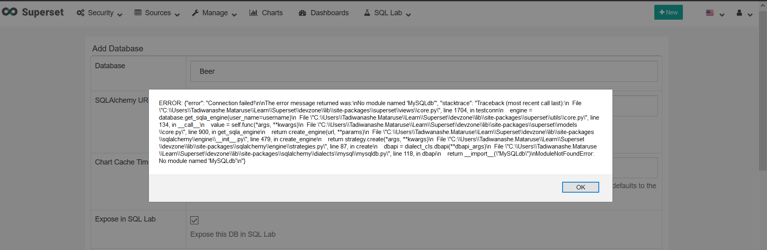

**Solution:** Do a **pip list**

Check to see if MySQL driver is available or not. Most probably the driver will be missing, so run the following command: **pip install mysqlclient**

**ERROR: module 'signal' has no attribute 'SIGALRM'**

**Solution:** This is because Windows does not have a signal alarm.

**ERROR: 'charmap' codec can't encode character '\u0107' in position 8: character maps to <undefined>**

**Solution:**

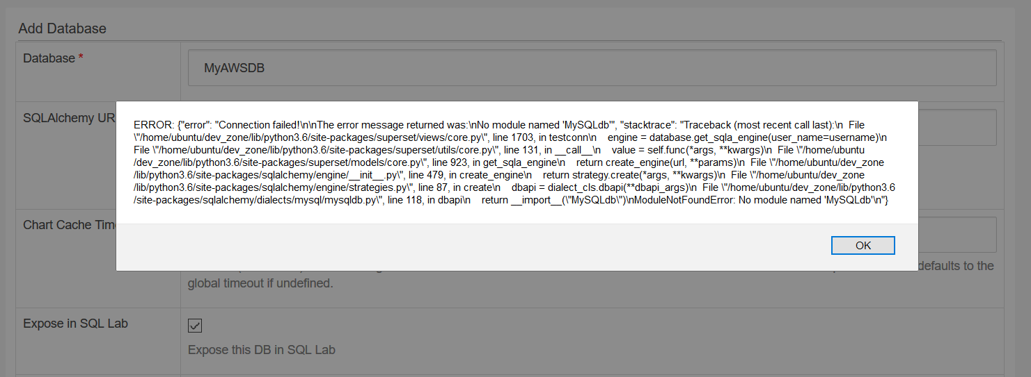**Error: Insert**

**Error No. 2003. Can't connect to mysql server**

**ERROR: CSV UPLOAD**

**Solution:**

Usually this error comes because you will have either installed Superset with root privileges, “sudo” OR

Generally your CSV file will be too big for Superset to upload before timeout.